The University uses emails for communicating with job applicants. This document relates to the manual email sent to applicants from the Recruitment module about a specific vacancy.

For guidance on automatic emails refer to:

This guide covers the following process steps:

1. Create a new email template 1
2. Amend an existing email template 3
3. Delete an email template 3

Knowledge article: Letter and Email Templates Knowledge Article_V0.4

Document Version Control
Change History/Review Details
Date | Version | Review by | Summary of Change
 | 1.0
6/11/20 | 2.0 | HC | Updated for V28

Core|Portal > People Management > Data Centre > HR Admin HR Setup Settings > Document and Email templates

Create a new email template

From the Templates tab click on ACTIONS and choose Create Email Template

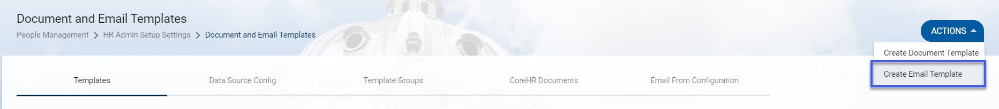

1.1. Template Details

Field Name (* mandatory) | Description
Template Name* | Free text – enter as appropriate
Called From* | Select from the drop-down list – usually Employee Search or View Applicants  NB: once this is selected the Data View Source options will appear. This determines which field are available to insert into the merge fields
Template Group* | Select from the drop-down list:  Employee Search or View Applicants  Post Appointments or Recruitment
Data View Source* | Select from the drop-down list  NB items available to select are dependent on what’s chosen in the ‘Called From’ field – usually Employee Dashboard or View Applicants

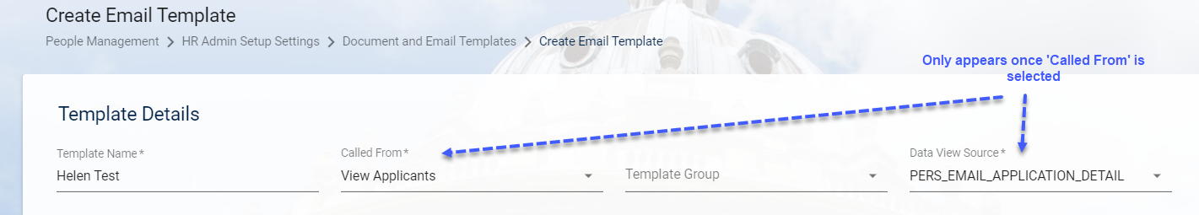

1.2. Email Editor

Field Name (*mandatory) | Description
Subject | Free text – enter as appropriate
Body | Free text – enter as appropriate (limited to 2000 characters including spaces)

    - You can type text directly into the body of the email or copy and paste from another document.

    - To insert merge fields, ensure the cursor is in the correct place then click on the required field from the menu.

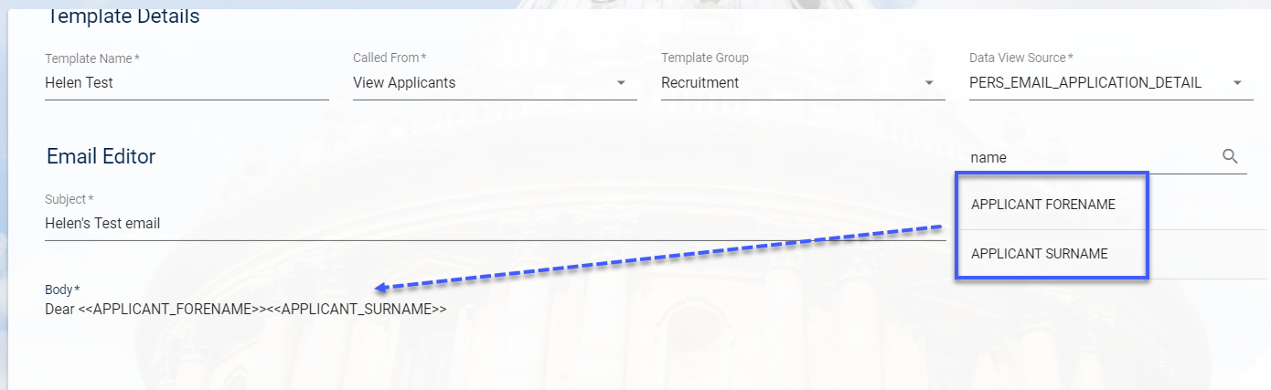

    - SAVE. You will automatically be taken back to the Templates screen.

    - The new email will appear in the list of Document and email templates

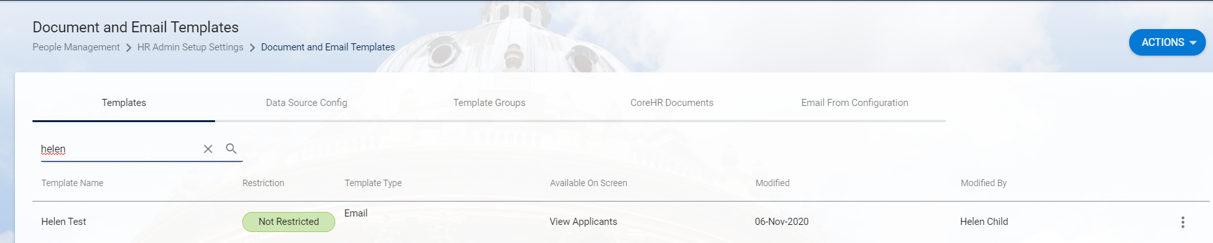

Amend an email template

NB: Editing active templates has not been tested and we do not know what the implications are of amending email templates that have been used/sent

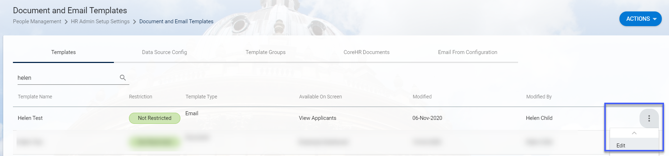

However, if you do need to edit a template click on the ellipses against the relevant template and choose ‘Edit’.

Make the required changes and SAVE

Delete an email template

Deleting active templates has not been tested and we do not know what the implications are of deleting email templates that have been used/sent.

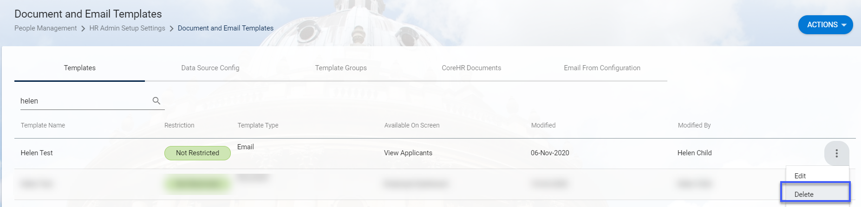

However, if you do wish to delete a template, click on the ellipses against the relevant template and choose ‘Delete’.

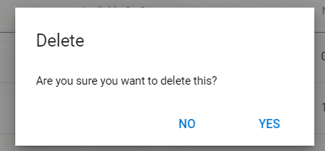

To confirm that you want to delete the email choose YES.

